Lab 9: Secure and Harden the Linux Operating System

Answer Sheet

All numbered questions are worth points as indicated.

1. Create a user account for a user ‘alice’ and assign a password of your choosing (4pts)

Provide a screenshot of the command(s) and result of executing this command(s) on the lab answer sheet.

1. Create a user account for a user ‘bob’ and assign a password of your choosing (4pts)

Provide a screenshot of the command(s) and the result of executing this command(s) on the lab answer sheet.

1. The user alice will be a system administrator, add her to the proper group so she may use the sudo command (4pts)

Provide a screenshot of the command(s) and the result of executing this command(s) on the lab answer sheet.

1. Execute the appropriate command so that root users will not be able to log in. If you did this previously during the lab instruction execute the same command again, it will work 4pts)

Provide a screenshot of the command(s) and the result of executing this command(s) on the lab answer sheet.

1. Execute the appropriate command to list the currently configured software update repositories (4pts)

Provide a screenshot of the command(s) and the result of executing this command(s) on the lab answer sheet.

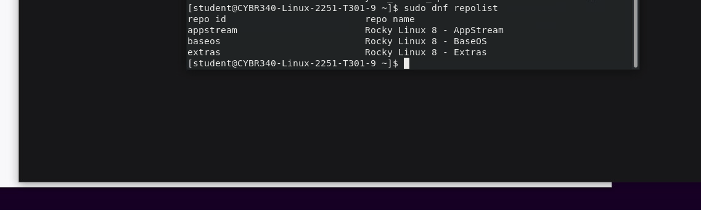

1. Configure the system so all passwords must have a minimum length of 12 characters and passwords must have 3 of the 4 classes of uppercase, lowercase, numbers, and / or symbols (5pts)

Provide a screenshot of the appropriate portions of the modified configuration file required to implement these password requirements.

1. What is the current default zone of your systems host firewall (4pts)

Provide a screenshot of the command(s) and the result of executing this command(s) on the lab answer sheet.

1. Change your host firewall’s default zone to the dmz zone, (4pts)

Provide a screenshot of the command(s) and the result of executing this command(s) on the lab answer sheet.

1. This system will host a web server, configure the firewall to allow https traffic through, make the change so it will survive reboots, and load the rules so the change is immediate (4pts)

Provide a screenshot of the command(s) and the result of executing this command(s) on the lab answer sheet.

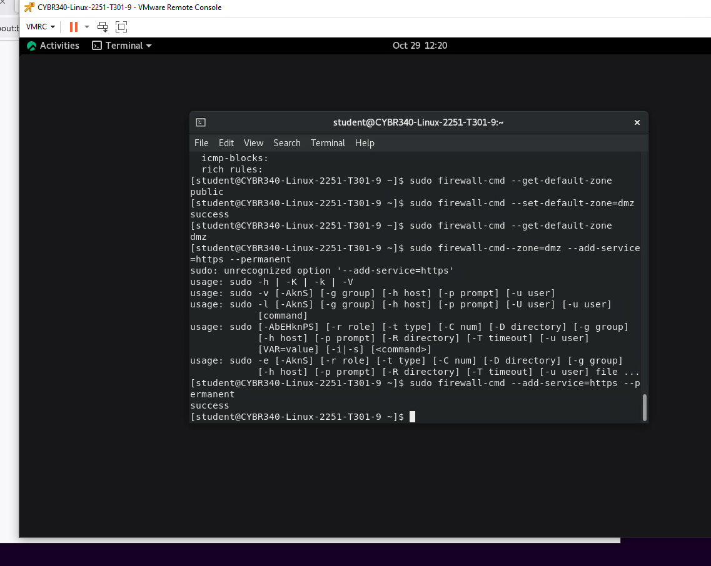

1. Your organization is adding a MySQL database which must communicate with your Linux system. MySQL will run on its default TCP port 3306. Update the firewall to permit the desired traffic, make the change so it will survive reboots, and load the rules so the change is immediate (5pts)

Provide a screenshot of the command(s) and the result of executing this command(s) on the lab answer sheet.

1. Is the secure shell service (sshd) running? (4pts)

Provide a screenshot of the command(s) and the result of executing this command(s) on the lab answer sheet.

1. What are the most recent security events which were logged by the system, (hint, you will need the tail command) (4pts)

Provide a screenshot of the command(s) and the result of executing this command(s) on the lab answer sheet.

